# Electronics and sensors.

## Onboard computers.

The EX1 rover embedded system in its current configuration makes use of two onboard computers so as to minimize computing load and facilitate the parallelization of tasks during development.

### Primary Onboard Computer (P-OBC)

As the name suggests, the P-OBC is the main computer in charge of all the high-level functionality of the rover. It consists of an **NVIDIA Jetson TX2 Development Kit** (see Fig. 4-1). The P-OBC is the most powerful of the two computers onboard. Additionally, all the incoming telemetry data from proprioceptive sensors is received by and stored in the P-OBC. The rover functionality handled by the P-OBC includes:

* Communication with Ground Control Station (GCS) to retrieve orders.
* High-level to low-level communication of main locomotive tasks (i.e., driving and steering).
* Communication with the ADE to receive telemetry data.
* Storage of telemetry data.

The P-OBC was slightly modified so as to activate Auto-Power-ON mode, i.e., a mode that allows the P-OBC to turn ON when VCC is detected.

The P-OBC was initially flashed using **JetPack 4.3 SDK**[1]. Currently, a linux for tegra (L4T) operating system running **Ubuntu 18.04 LTS** is used in the P-OBC. General specifications of the P-OBC can be found in Table 4-1.

Future students can decide whether to use the P-OBC for additional tasks related to increasing the autonomous capabilities of the rover; examples of these tasks include the reception and manipulation of incoming data from the NavCam and/or the LIDAR. Nonetheless, to facilitate this task a secondary computer was included in the design.

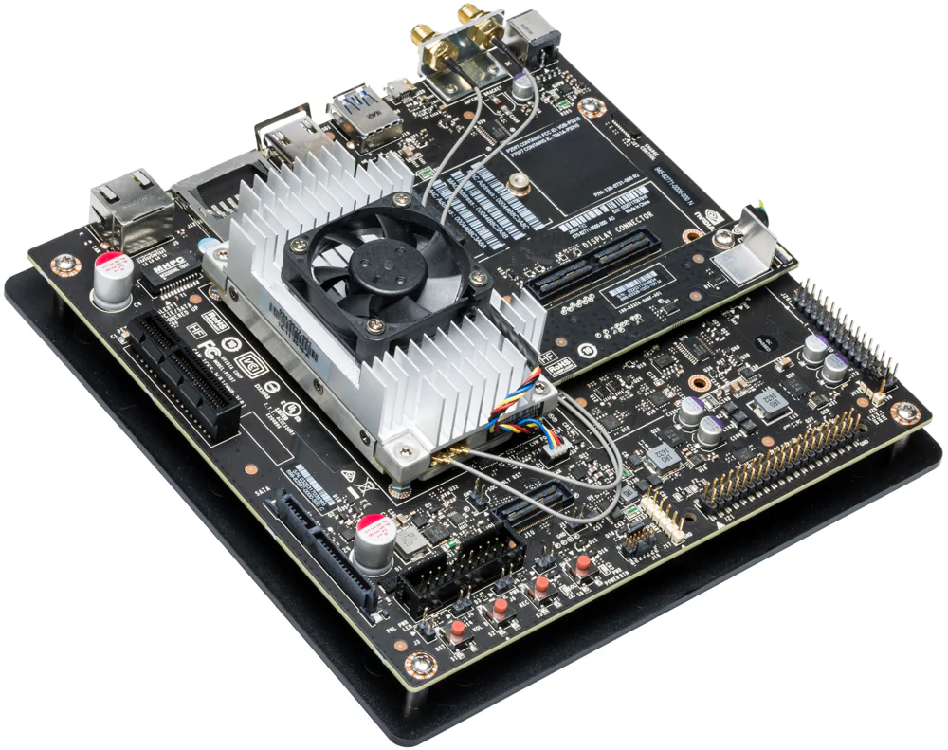

***Fig.4-1****. NVIDIA Jetson TX2.*

***Table 4-1.*** *NVIDIA Jetson TX2 and NVIDIA Jetson Nano general characteristics.*

|  |  |  |
| --- | --- | --- |
| Specs | Jetson TX2 (P-OBC) | Jetson Nano (S-OBC) |
| CPU | ARM Cortex-A57 (quad-core) @ 2GHz +  NVIDIA Denver2 (dual-core) @ 2GHz | 64-bit Quad-core ARM A57 @ 1.43GHz |
| GPU | 256-core Pascal @ 1300MHz | 128-core NVIDIA Maxwell @ 921MHz |
| Memory | 8GB 128-bit LPDDR4 @ 1866Mhz | 59.7 GB/s | 4GB 64-bit LPDDR4 @ 1600MHz | 25.6 GB/s |
| Storage | 32GB eMMC 5.1 | MicroSD card (16GB UHS-1 recommended minimum) |
| Wireless | 802.11a/b/g/n/ac 2×2 867Mbps | Bluetooth 4.1 | M.2 Key-E with PCIe x1 |
| Ethernet | 10/100/1000 BASE-T Ethernet | Gigabit Ethernet (RJ45) |
| USB | USB 3.0 + USB 2.0 | 4x USB 3.0 A (Host) | USB 2.0 Micro B (Device) |
| Misc I/O | UART, SPI, I2C, I2S, GPIOs | UART, SPI, I2C, I2S, GPIOs |
| Dimension | 17 x 17 cm | 10 x 8 cm |
| Temp. Range * | -20º/ 80ºC | -20º/ 80ºC |
| Power** | 7.5 W | 10 W |

*Operating temperature range, TTP max junction temperature.

**Typical power consumption under load, input 5.5-19.6 VDC.

### Secondary Onboard Computer (S-OBC)

As previously mentioned, a secondary computer was included in the design. This decision was made with the objective of minimizing the number of tasks handled by the P-OBC while parallelizing heavy computational tasks often associated with the manipulation of visual data. Overall this will result in faster computational times, a much-needed capability for high-speed, autonomous navigation.

In EX1 current configuration, the S-OBC is in charge of the manipulation of the L-TU and C-PTU as well as the reception and storage of both LIDAR and NavCam data. At the moment of writing, the S-OCB is still pending to be integrated into the final EX1 assembly. The general characteristics of the S-OCB can be found in Table 4-1.

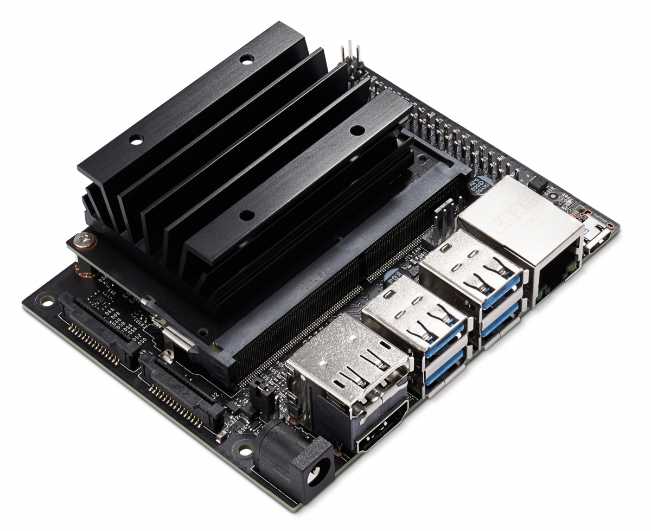

***Fig. 4-2.*** *NVIDIA Jetson Nano.*

## Actuated Drive Electronics (ADE).

The ADE is composed of all the different modules in charge of the control and actuation of the rover mechanisms (i.e., driving and steering motors). The respective datasheet of each module can be found in Appendix tk. Datasheets.

### Driving motor unit.

EX1 wheels are independently actuated by **Maxon© DCX32L GB KL 36V, ⌀32mm, 70W** motors. Each motor mounts a **Maxon© GPX32HP 62:1** planetary gearhead and a **Maxon© ENX10 EASY 1024IMP** embedded quadrature encoder.

### Steering motor unit.

EX1 wheels are also independently steered by Maxon© **RE-Max 17 GB, ⌀17mm, 4.5W** motors (part number 216013). Each motor mounts a **Maxon© GP16A ⌀17mm, 5.4:1** planetary gearhead (part number 118184) fixed to a secondary 100:1 gear interface providing a **total reduction ratio of 540:1**. Additionally a **Maxon© MR Type M 128-512 CPT, ⅔ Channels** embedded quadrature encoder (part number 201940) is built in each motor.

### Motor controller.

The motor controllers consist of a programmable **Hibot Titech M4 development board**, which makes use of an **ARM M4 cortex-based microcontroller (STM32F407IG)**. These microcontrollers are used as the low-level interface between the P-OBC and the different units comprising the locomotion system (i.e. motor drivers, motors, and sensors). One motor controller per rocker is used. This means that 4 motors (2 driving motors and 2 steering motors) and each respective driver are controlled by one single microcontroller. An image of the motor controller used is shown in Fig. 4-3(a).

### Motor driver.

Each individual driving and steering motor makes use of a **Hibot UM 1XH DC motor driver.** These motor drivers consists of a full H-bridge without a charge pump and are controlled via two external Pulse Width Modulation (PWM) signals. An image of the motor driver used is shown in Fig. 4-3(b).

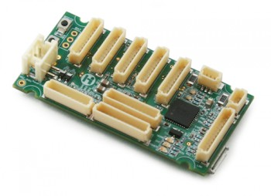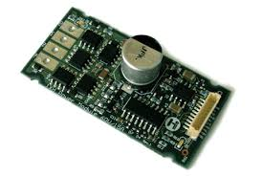

*(a) (b)*

***Fig. 4-3.*** *Hibot (a) motor controller and (b) motor driver units.*

## Rocker Interface Unit (RIU)

The Rocker Interface Unit (RIU) is a large PCB in which the individual control units of the ADE (i.e., motor controllers and drivers) for both rockers are integrated alongside other modules required for connectivity, data communication, and data stabilization. Each rocker consists of one potentiometer (to measure the rocker angle), 2 steering motors and 2 driving motors with their respective controller, drivers, and encoders. The RIU receives power for each component of the ADE directly from the Power Distribution Unit (PDU)(for details on the Power System refer to Chapter 5 of this manual). Rocker potentiometers, driving and steering motors, motor controllers, motor drivers, and encoders for both rockers are all assembled directly into the RIU. A 3D view and a top view of the RIU can be seen in Fig.4-4 and Fig.4-5, respectively. The different connections included in the RIU are also displayed in Fig. 4-5.

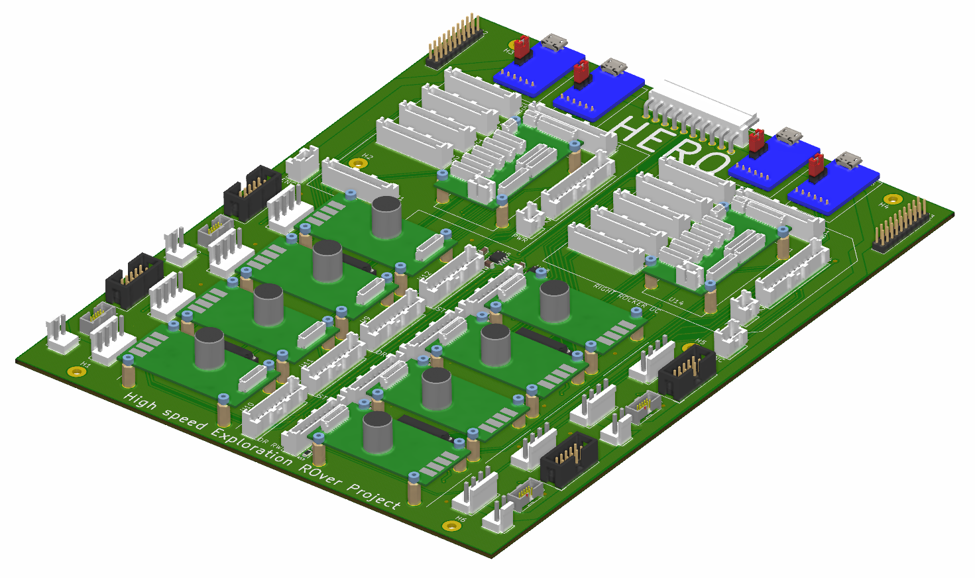

***Fig. 4-4.*** *3D view of the Rocker Interface Unit (RIU).*

The RIU consists of two identical connectivity diagrams—one for each rocker—as shown in Fig. 4.7. It allows all the logical signals and power to be routed towards each respective unit of the ADE. The RIU was designed taking into account the mechanical location of the rocker components. Some of the additional units available in the RIU, which are specified in Fig. 4-5, are defined below.

#### Power connector

It provides the RIU with the power lines required for each of the ADE components and data transfer lines connected to it. Input voltages include 36V, 24V, 12V, and 5V. More details about the power system is provided in Chapter 5.

#### FTDI

A small unit used as an interface for serial communication. FTDI units are in charge of translating the TTL-UART signal from the microcontrollers into the USB protocol required by the P-OBC, and *vice versa*.

#### Line receivers

A unit that consists of an integrated circuit (IC) from Texas Instrument, referenced number SN75175. The prime objective of this unit is to convert the differential output from the built-in encoders of the driving and steering motors into a logic TTL output, directly readable by the motor controllers.

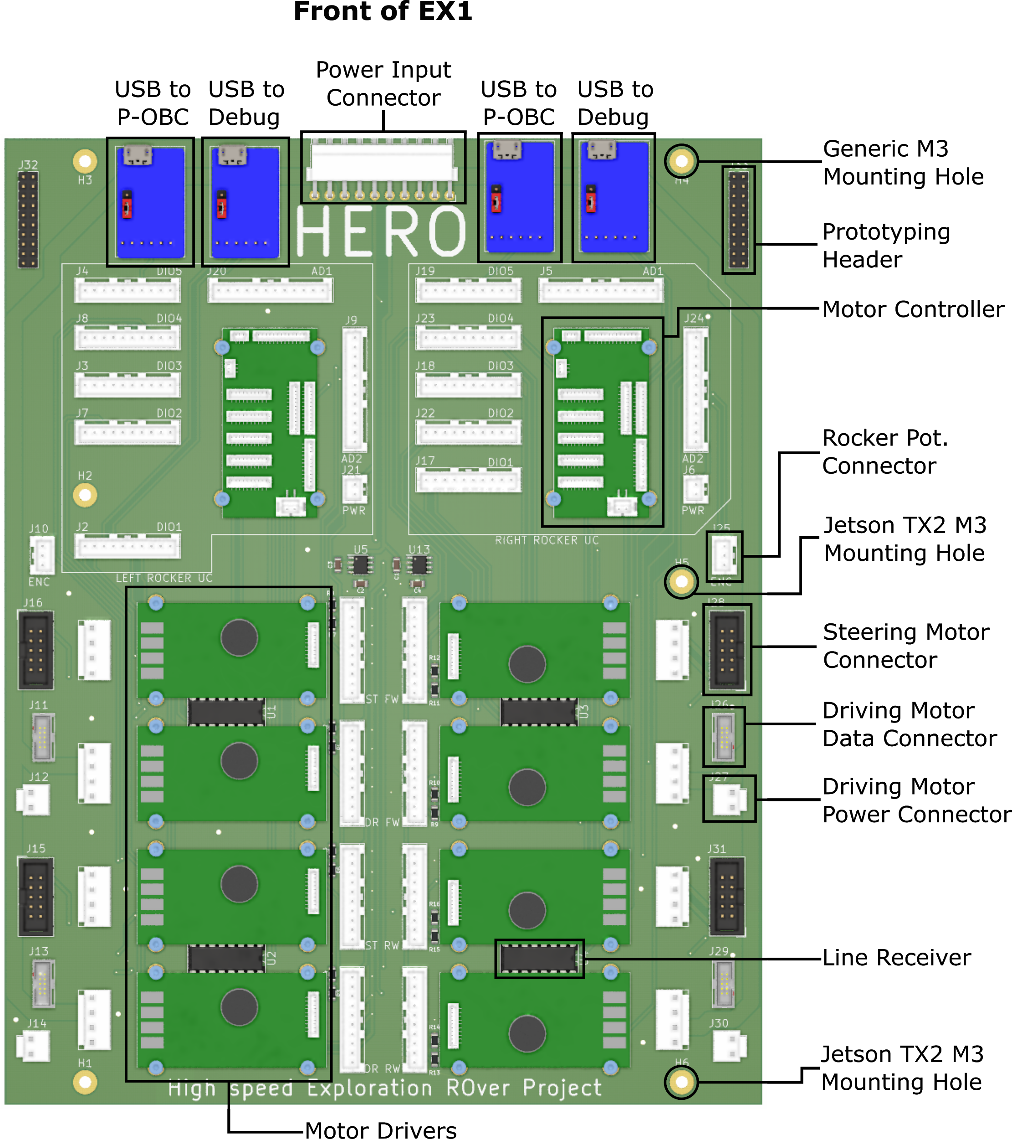

***Fig. 4-5.*** *Top view and individual connectors of the Rocker Interface Unit (RIU).*

#### Current sensing bridge

A unit that consists of a bridge made out of passive components. This was required in order to lower the analog output voltage of the current sensing device built inside the motor driver (from 5V to 3.3V). In addition, it provides low-pass filtering for this signal, smoothing out the effects of the PWM control of the motor. This allows for “average” current readings over a given PWM period, making the readings independent of the actual reading time.

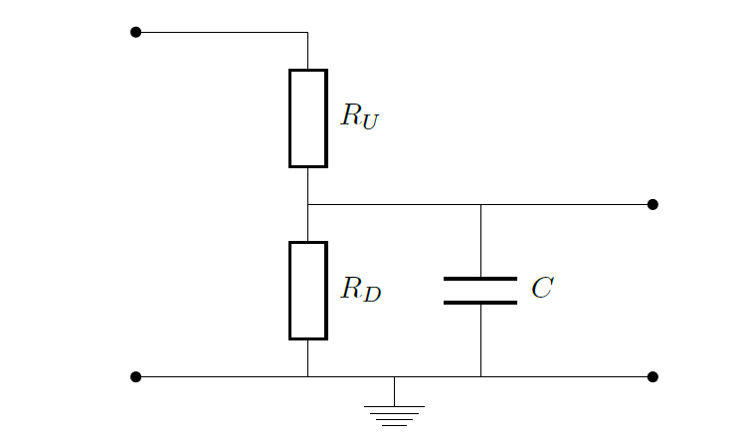

***Fig. 4-6.*** *Schematic of the current sensing bridge built into the RIU.*

#### USB to debug

Two additional FTDI USB ports were included in the design of the RIU (see Fig. 4-5). These ports have been routed directly to additional UART ports on the motor controllers. These ports were included to allow future communication to an additional computer, mainly for debugging purposes, while the rover is being operated in a nominal state (i.e., without the need to disconnect other USB communication paths).

#### Prototyping header

An extra header not connected to anything in particular. It was included in the design of the RIU in order to add a generic connector in the event that an additional component or a prototype of some sort needs to be included in the design. This header allows future students to add new components without the need to use additional wires or modify the design.

*Note: If an extra connection is needed, one can directly solder wires from the pins of the micro controllers to the right pins of the header on the underside of the RIU.*

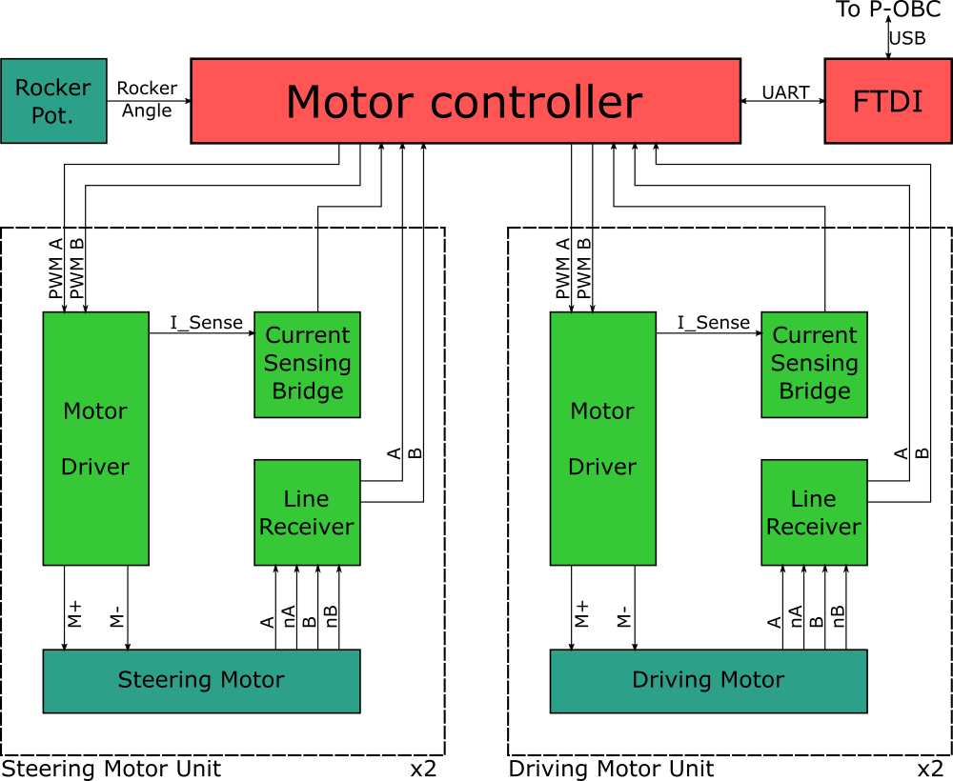

***Fig. 4-7.*** *Connectivity diagram for half of the Rocker Interface Unit (RIU), i.e., all the modules for one single rocker.*

The design of the PCB also required to map each device Input/Output to the right microcontroller pin, a reference of which is available in Table 4-2.

***Table 4-2****. Pinout reference for the microcontroller.*

|  |  |  |  |  |
| --- | --- | --- | --- | --- |
| Function | Description | MCU Pin | Hibot TiTech Pin | Alt. Function Used |
| ENC_ST_FW_1 | ENCoder FSM chan. A | E9 | DIO3_1 | TIM1_CH1 |
| ENC_ST_FW_2 | ENCoder FSM chan. B | E11 | DIO3_3 | TIM1_CH2 |
| ENC_ST_RW_1 | ENCoder RSM chan. A | B4 | DIO1_6 | TIM3_CH1 |
| ENC_ST_RW_2 | ENCoder RSM chan. B | C7 | DIO1_7 | TIM3_CH2 |
| ENC_DR_FW_1 | ENCoder FDM chan. A | A15 | DIO1_1 | TIM2_CH1 |
| ENC_DR_FW_2 | ENCoder FDM chan. B | B3 | DIO1_2 | TIM2_CH2 |
| ENC_DR_RW_1 | ENCoder RDM chan. A | H10 | DIO2_6 | TIM5_CH1 |
| ENC_DR_RW_2 | ENCoder RDM chan. B | H11 | DIO2_7 | TIM5_CH2 |
| MOT_ST_FW_1 | MOTor FSM pwm A | I5 | DIO4_1 | TIM8_CH1 |
| MOT_ST_FW_2 | MOTor FSM pwm. B | I6 | DIO4_3 | TIM8_CH2 |
| MOT_ST_RW_1 | MOTor RSM pwm A | I7 | DIO4_6 | TIM8_CH3 |
| MOT_ST_RW_2 | MOTor RSM pwm B | I2 | DIO4_8 | TIM8_CH4 |
| MOT_DR_FW_1 | MOTor FDM pwm A | D12 | DIO2_1 | TIM4_CH1 |
| MOT_DR_FW_2 | MOTor FDM pwm B | D13 | DIO2_2 | TIM4_CH2 |
| MOT_DR_RW_1 | MOTor RDM pwm A | D14 | DIO2_3 | TIM4_CH3 |
| MOT_DR_RW_2 | MOTor RDM pwm B | D15 | DIO2_4 | TIM4_CH4 |
| CUR_ST_FW | CURrent sensing FSM | F3 | AD2_02 | ADC3_IN9 |
| CUR_ST_RW | CURrent sensing RSM | F4 | AD2_03 | ADC3_IN14 |
| CUR_DR_FW | CURrent sensing FDM | F5 | AD2_04 | ADC3_IN15 |
| CUR_DR_RW | CURrent sensing RDM | F6 | AD2_05 | ADC3_IN4 |
| ANG_RK | AMG;e of RoCKer | F7 | AD2_08 | ADC3_IN5 |
| UART_RX_COM | UART RX COMM to P-OBC | G9 | DIO5_7 | USART6_RX |
| UART_TX_COM | UART TX COMM to P-OBC | C6 | DIO5_6 | USART6_TX |
| UART_RX_DBG | UART RX DeBuG | B10 | DIO1_3 | USART3_RX |
| UART_TX_DBG | UART TX DeBuG | B11 | DIO1_4 | USART3_TX |

## Lights Control Board (LCB).

As briefly mentioned in Chapter 3, the EX1 rover mounts a set of lights intended to be used during low-visibility testing activities. The light set includes two sets of LEDs housed within the Optical Bench of the NAVMAST and a LED bar attached to the front chassis panel. The main functionality of the LCB is to allow the operator to switch the lights on and off from the joystick of the P-OBC as well as to manually and independently regulate the brightness of each light source.

A classical way to control LEDs is to use a MOSFET as a switch and a series of resistors to limit current. This method has the advantage of being simple. However, one major drawback of this simple methodology is that, as time goes by, the LED heats up and its internal resistance subsequently decreases allowing more current to pass through. Over time, the brightness would increase as well as the likelihood of the LED being burned by overcurrent. This issue is often negligible for low-brightness LEDs but it should be considered for higher power applications.

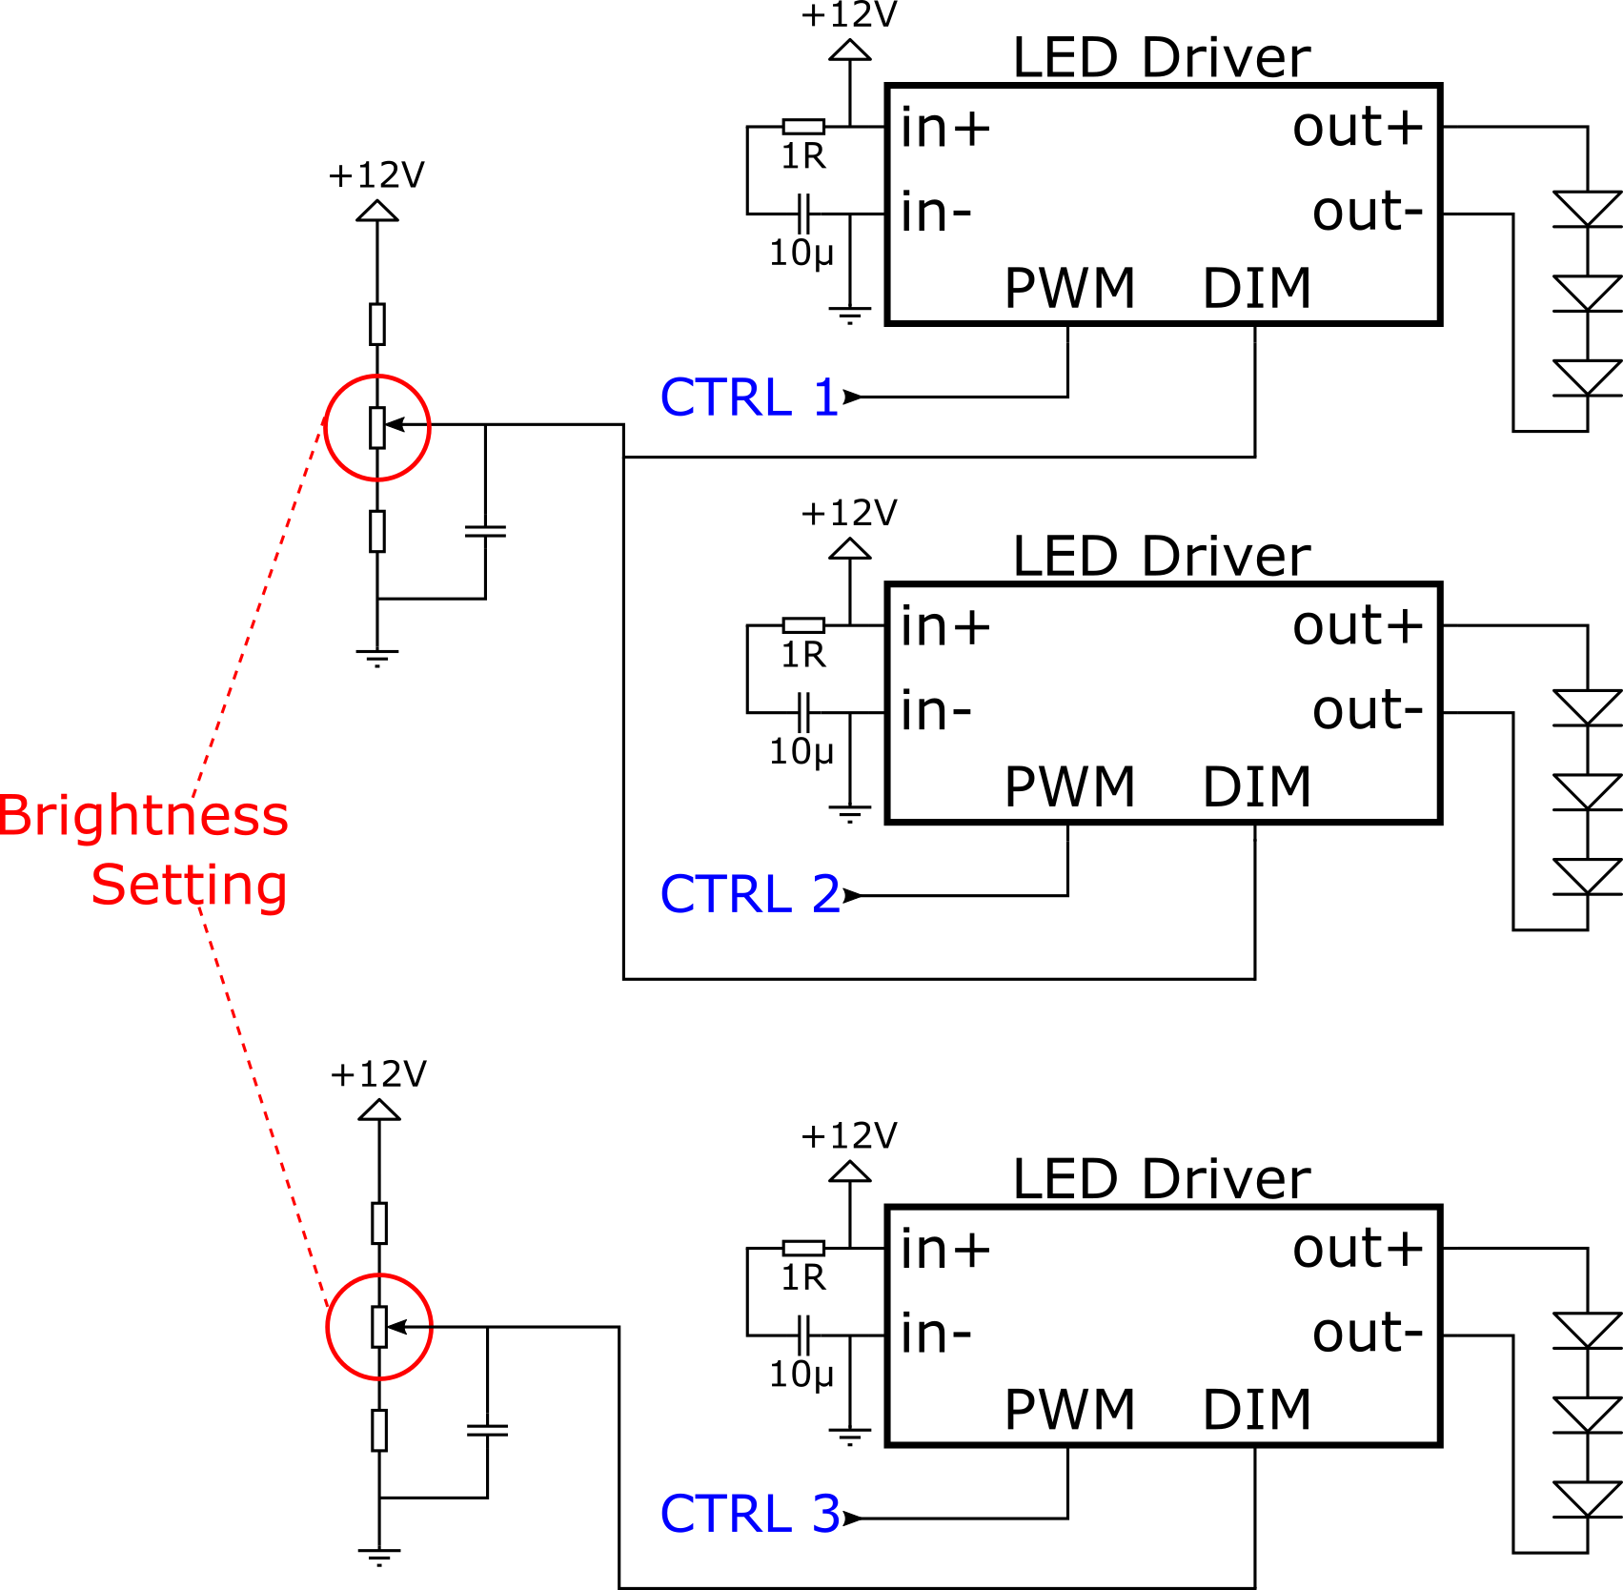

***Fig. 4-8****. Schematic of the Lights Control Board (LCB) circuit.*

In the case of EX1, we opted for the use of constant-current LED drivers instead. These drivers are capable of adapting their output voltage to match the required current. The drivers used are **Recom RCD-24-0.35 LED Driver,** alongside a couple of resistors, capacitors, and trimmer potentiometers to complete the circuit. A schematic of the LCB can be seen in Fig. 4-8. The voltage on the DIM pin adjusts the current passing through the LEDs, acting as an analog dimmer. The PWM pin provides the ON/OFF functionality also known as PWM dimming (more information can be found in the LED driver datasheet, see *Appendix C - Datasheets*). In order to avoid the need to generate PWM signals from the P-OBC, in its place we opted for analog dimming and the PWM pin was used as an ON/OFF switch.

***Table 4-3****. Description of connectors in the Lights Control Board (LCB).*

|  |  |
| --- | --- |
| Port | Properties |
| P-OBC CTRL | CTRL pins to turn ON/OFF each light source. ON = 0V, OFF > 2.9V. |
| POWER_IN | 12V Power input connector. |
| OUTPUT 1 | 0-110 mA, controlled by Trimmer B [LED Bar] |
| OUTPUT 2 | 30-70 mA, controlled by Trimmer A [Right “eye”] |
| OUTPUT 3 | 30-70 mA, controlled by Trimmer A [Left “eye”] |

The final configuration of the LCB is shown below. For the respective GPIO pins used in the P-OBC and their configuration, refer to Section 8.4.

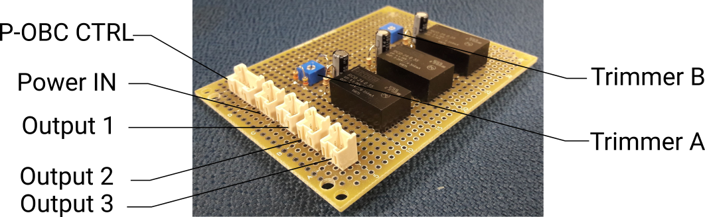

***Fig. 4-9.*** *Lights Control Board (LCB).*

## Inertial Measurement Unit (IMU).

Directly mounted to the SVM and connected via USB to the P-OBC is a **USB Output 9-axis IMU sensor module** (MPU9250) from RT Corporation. IMU data, including values from the built-in temperature sensor, are directly sent and stored in the P-OBC. The IMU sensor module was mounted as close as possible to the top surface of the SVM and as far as possible from strong electromagnetic field sources (i.e., inductors such as motors and power supplies) so as to minimize noise and data interference.

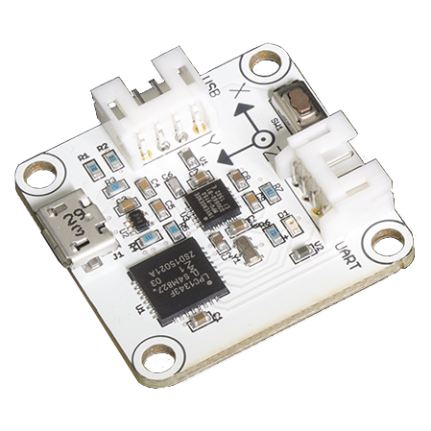

***Fig. 4-10.*** *IMU sensor module.*

1. JetPack provides the Jetson Developer Kit with the latest OS image, libraries and APIs, samples, and documentation, as well as developer tools.